2019 Western Michigan CPCU
Charity Golf Outing

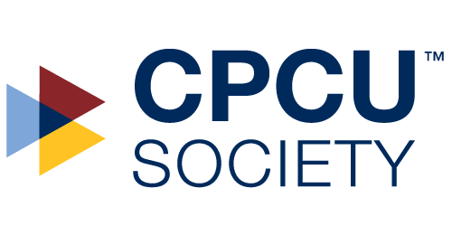
Join the Western Michigan CPCU for a fun day of golf and networking at the newly remodeled The Legacy at Hastings on June 18th, 2019

PROFITS TO BENEFIT:

Local college students and insurance professionals pursuing careers in the Insurance and Risk Management fields

Outing Details Tuesday, June 18th, 2019

Location The Legacy at Hastings - 1550 N Broadway Hastings, MI

Format Four (4)-Person – 18 Hole Scramble Format
Make up your own foursome or let us assign you

Schedule 10:00 a.m. – Registration /Driving Range
11:00 a.m. – Shotgun Start
4:00 p.m. – 5:00 p.m. Reception/ Dinner

Cost (Per Person) $75.00 per person including Dinner (or $300 Per Team)

$20.00 - Dinner/Reception Only - Hamburger/Brat Cookout - Beginning at @ 4:30PM

Payment Options
- Make a Check Payable to - Western Michigan CPCU with completed form and
MAIL TO: Kim Ward
Director of Actuarial Services
Hastings Mutual Insurance Company
404 E Woodlawn Avenue
Hastings, MI 49058
- PayPal / Credit Card Payment - Complete form and send via email and make your payment per Secured CPCU Chapter PayPal account (PayPal account not necessary) or via Credit Card – Please email Kim Ward at kward@hastingsmutual.com for additional information for this option.
---------------------------------------------------------------------------------------------------------------------------------------------------

$75.00 Golf per Person w/ dinner $ Name:
$20.00 Reception/Dinner Only $ Co./ Agency:
TOTAL COST $ Email:

Please assign me to a foursome Yes No
Our foursome is made up of the following:
If you or your company can donate prizes for the golf outing, please bring to the outing. Thank you in advance for your contributions!
Contact Beau Barnum beaubarnum@michiganinsurance.com or Kim Ward kward@hastingsmutual.com) with any questions.

1.
2,
3.
4.

