ANNUAL GOLF OUTING & FUNDRAISER
Donated funds will be used for chapter scholarships, charitable
donations and to encourage students to join the insurance industry

When Tuesday, June14, 2016
Shotgun start at 1:00 PM SHARP ~ Please Arrive by 12:30 PM
Where 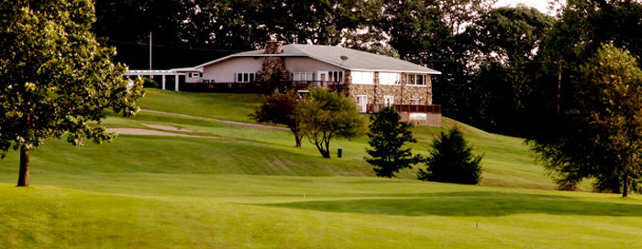

Hastings Country Club 1550 N Broadway Hastings MI (269 945-2756)
Link for map & directions: http://hastingscc.com/contactus.htm

What Four (4)-Person Scramble Format
Make up your own foursome or let us assign you

Cost (Per Person) Green fees + 1/2 Cart; Shotgun @ 1 PM
$50.00 CPCU Members
Golf fees do not include cookout
$55.00 Non-Members

Hamburger/Brat Cookout
Beginning at @ 5-6 PM
$20.00

How Payment of golf fees must be made by Friday, June 10, 2016
(Unless other arrangements are made in advance)

Send CHECK ONLY (payable to Western Michigan CPCU) for Golf Fees and/or cookout with form below to:
MAIL TO: Janie Hathaway JD, CPCU
AVP Insurance Operations
Hastings Mutual Insurance Company
404 E Woodlawn Avenue, Hastings, MI 49058
___ $50.00/$55.00 (Non-members) Golf Fees Per Person $ _______
___ $20.00 Hamburger/Brat Cookout following Golf $ _______
___ TOTAL $ _______
Name: ______________________________________
Please assign me to a foursome: ____ Yes ___ No
I will play in the following group: _________________________________
_________________________________
_________________________________
_________________________________

If you or your company can donate prizes for the golf outing please bring to the outing. Thank you in advance for your contributions! Contact Beau Barnum (beaubarnum@michiganinsurance.com ) or Krista Loftus (kloftus@hastingsmutual.com)with questions.

